**GUI GUIDE**

Have you ever opened GUI and wondered exactly which template is used for what activity? If you answered yes, then you are in the right place! Below is a GUI guide, where you can learn more about each section and when each activity should be used. The sections used are outlined in the below categories:



**CHG – Change -** used when any type of endorsement or change is made to a policy. Be sure the template matches the change you wish to process.

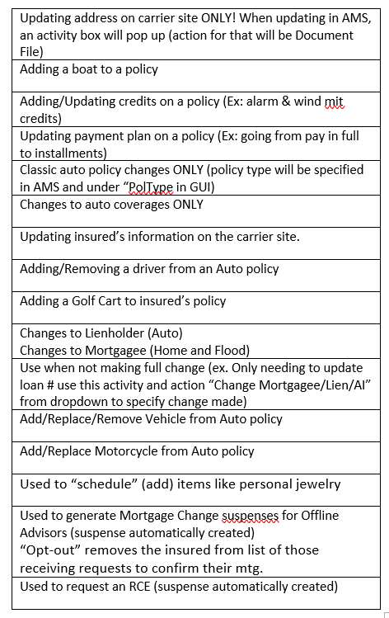

**GEN – General –** Used when needing to notate general items in AMS.

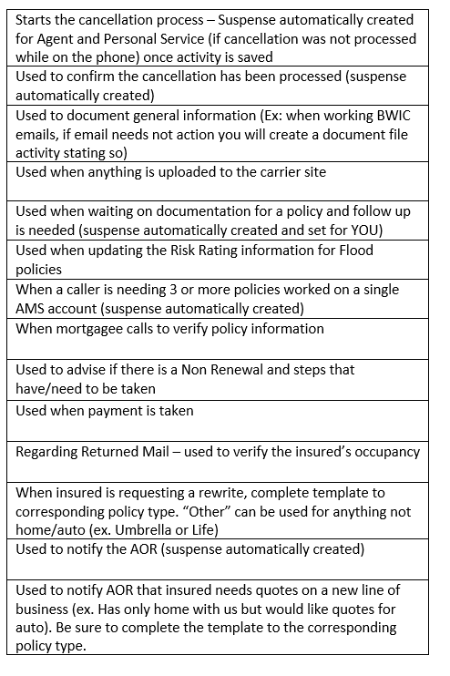

**REN – Renewal –** Specifically used to document Renewal activities.

|  |
| --- |
| Used to advise agent of renewal status (Ex: Insured did not pay renewal, policy lapsed) |
| Used to document Renewal term has been paid – Be sure to close out the Renewal suspense if paid |
| Used to follow up on Renewal term that is set up on auto pay so we can ensure payment was made |
| Used if we need to follow up with Mortgage Company and request payment (suspense automatically created) |

**COMM – Communication -** Used to document all communication to/from customers, third parties, agents, etc.

**RTG- Routing –** This tab will only be used by the Routing Team.

